Our trip to Marsala: An unforgetteable experience
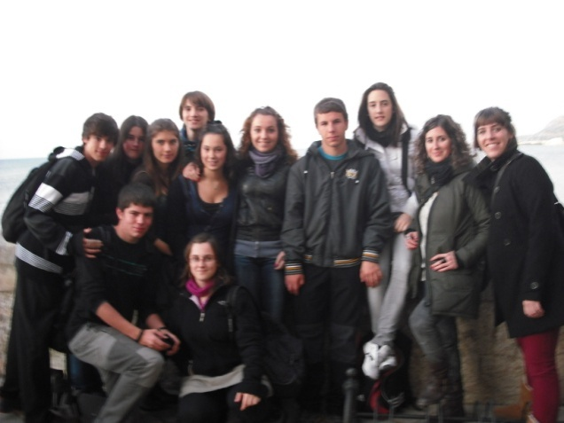
Our trip to Marsala started the on 11th December 2011, when we arrived to the airport in Italy. We were very nervous, but when the door of the airport opened we met our new friends. For a week, we did different activities and we enjoyed ourselves with our new mates and their friends.

On the first day, we went to Liceo Scientifico Statale Pietro Ruggieri and the head teacher welcomed us. We did a lot of activities there with the Italian teachers and students: we received an Italian lesson, we did an experiment in the Science laboratory, we designed some logos for the project in the Art room…
Apart from that, we really enjoyed the visits to Palermo, Trapani and the Archaeological Park of Selinunte, were we had the opportunity to see some roman ruins and the beautiful Parliament of Sicily. Besides, the island of Mozia was a good place to learn more about the Phoenician civilization, walk a little around the island and to admire the landscape.
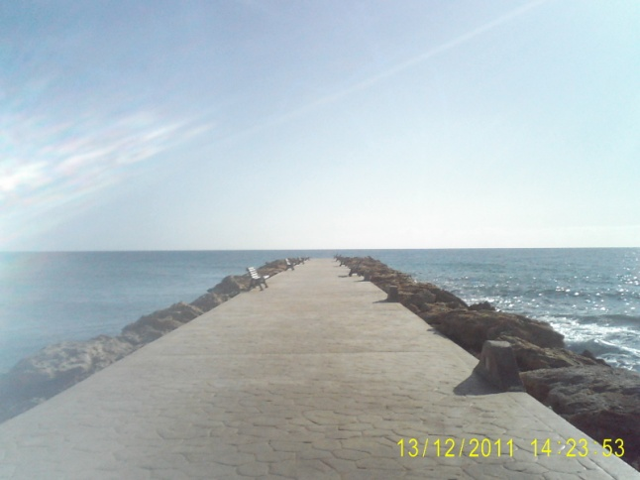
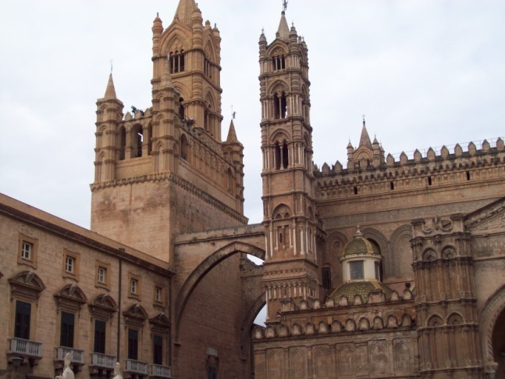

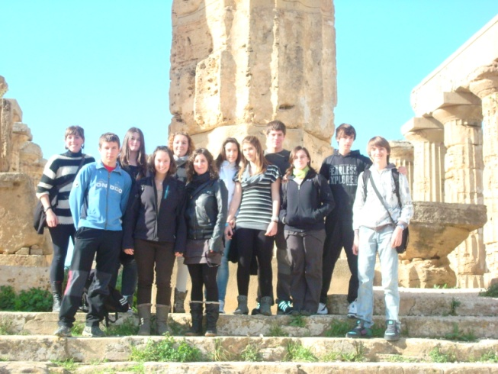

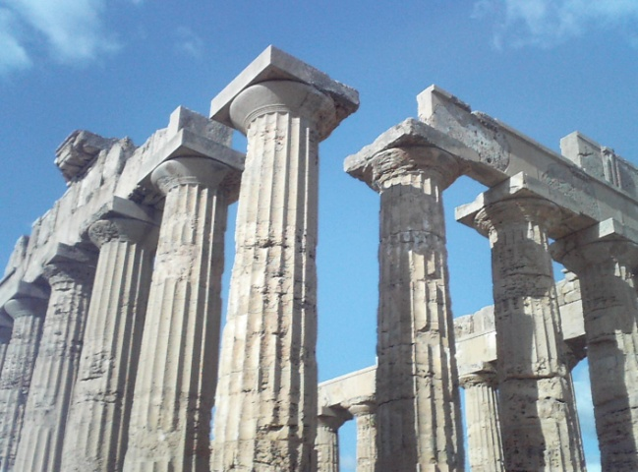

In addition, we had dinner in a pizzeria altogether: Italian and Spanish students, teachers and some new friends. We had a great time, and we liked the pizzas a lot.
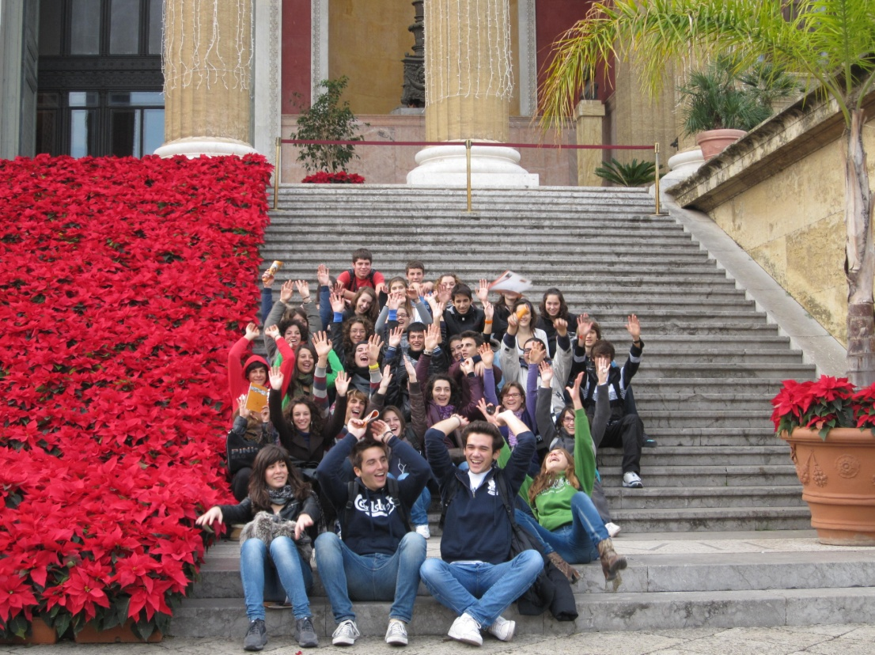
On the last day morning, all the families met in the airport to say ``Good bye´´ to the first part of the Comenius Project, and after taking some photos and crying a little, we returned to our country.

